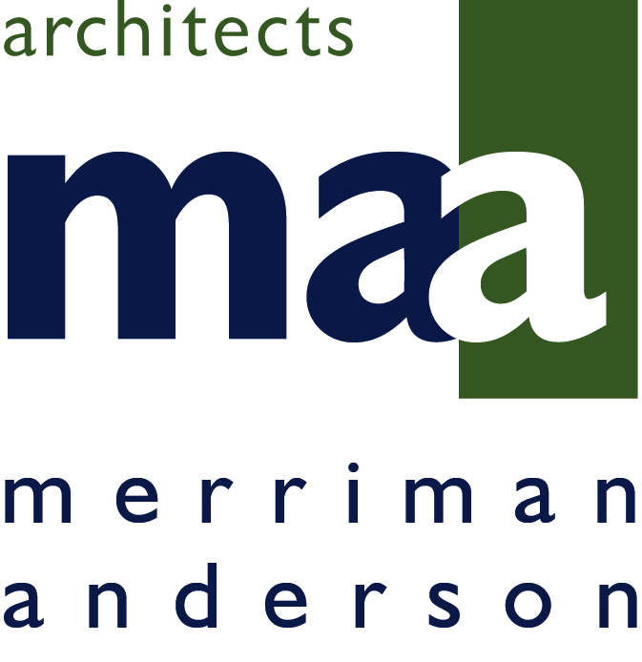

FOR IMMEDIATE RELEASE CONTACT: McClain Stone
214.352.5980
McClain@culverpr.com

Merriman Anderson/Architects, Inc. Reveals Masterplan
Seven new shareholders in place to propel firm’s innovation, growth, diversity

DALLAS – February 21, 2017 – Merriman Anderson/Architects, Inc. (maa) announces the promotion of seven associates from their Dallas office to shareholder/principal status. Attributing the success and growth of the firm to its talented staff, principals Jerry Merriman, Deby Merriman and Milton Anderson recently presented shareholder status to:

David Masters
John Carruth
Aimee Sanborn
Philip Siems
Adam Jones
Justin McCarthy
Jennifer Picquet-Reyes

This marks the second time in the firm’s 30-year history that shareholder status has been awarded to staff members; however, it is in keeping with the firm’s commitment of fostering innovation, growth and diversity. maa principals, Jerry Merriman, Deby Merriman and Milton Anderson believe their firm’s unique familial and symbiotic culture should be reflected in the firm’s ownership. The new principals were chosen to work with the owners to plan for continued excellence, implementation of the firm’s strategic plan and management of business growth.

maa is a multi-disciplinary architecture, design and planning firm offering a wide array of services for the built environment from master plan development to architectural design, interior design, 3D visualization, graphic design and construction document production. The firm’s renowned commitment to technology via 3-D Visualization, Virtual Reality and BIM (Building Information Modeling) is manifest in the promotion of John Carruth and Philip Siems, both who have been with maa for more than ten years and are credited with spearheading the firm’s technical innovation and expertise.

“Architectural firms are often times so consumed with servicing their myriad clients and projects, that they neglect to devise a masterplan for their own firm,” says president and founding partner, Jerry Merriman, AIA. “Deby, Milton and I feel strongly about sharing ownership of this firm with the talented human resources who have propelled our growth and reputation and will continue to help us innovate all aspects of our flourishing practice.”

“We take our cues regarding pace of growth from our founder, Jerry Merriman,” explains Milton Anderson, AIA, vice president and director of design. “Jerry and Deby established excellence, quality, respect and balance as core values when they began the firm in 1986. maa is very much a family atmosphere and just as you take care of your family at home, we believe in offering our employees career growth and stability for their futures. Having a growth plan also offers all of our current and future employees stability for their careers with us.”

Continuity in quality and service to clients, a healthy respect among the firm’s employees for each other and a passion for architecture and design are hallmarks of maa. The newest shareholders are a diverse group of individuals among varied disciplines. They are not all architects by design. Their individual responsibilities and strengths were thoughtfully planned to assure collaboration of ideas and service through the years to come.

“This group will nurture and grow the next group of stars in our company,” said Deby Merriman, co-founder. “They represent different management and leadership skills so that all areas of maa will continue to deliver the high-level of service our clients demand. We at maa rely on one another much as family members do. We have found this culture attracts the top talent we have and will continue to recruit.”

The firm’s annual planning meeting, Football Friday, is another example of maa’s unique camaraderie and familial culture. Both the Dallas and Austin offices are combined into teams to huddle and discuss topics such as work quality, efficiency, marketing and office culture. The teams present their ideas to the firm principals at the end of the day. Several of maa’s freshest practices have initiated from the annual all-office event. Football Friday is an opportunity for the firm’s employees to lay the groundwork for their collective futures.

The maa stamp can be seen on master planned developments, urban housing, office buildings, corporate facilities, hotels, hospitals, schools and retail projects, including interiors and signage, throughout the United States and internationally. Headquartered in Dallas, Texas, and with offices in Austin, Texas and Charlotte, North Carolina, the firm offers customized project solutions to a varied client portfolio. With nearly 90 employees, the award-winning firm is large enough to address broad and complex real estate developments, yet small enough to offer personalized service and accountability. maa associates have a reputation for design excellence and technical expertise, and for creating projects that are a synthesis of exceptional design, function and value.

Notable maa projects include Bell Helicopter Global Headquarters in Fort Worth, Texas; 1401 Elm/The Drever, in Downtown Dallas; Ethiopia Embassy Housing Addis Ababa in Ethiopia and Kinshasa Arena Kinshasa, DRC. The firm has completed projects in all 50 United States and 11 countries.

About MERRIMAN ANDERSON/ARCHITECTS, INC. (maa)

A Dallas based architecture & planning firm offering programming, urban planning, architectural design, space planning, interior architecture/design, graphic design, construction document production, construction observation, 3D visualization and facilities move coordination. With offices in Dallas, Texas; Austin, Texas; and Charlotte, North Carolina, maa provides services to clients on a national and international basis, emphasizing repeat clients as the heart of their practice. Each maa professional listens to the needs of the firm’s clients and works to meet their individual and specific schedule, budget and scope requirements. For more information, visit http://merriman-maa.com/.

# # #

